NAME: JUNAID GIRKAR

SAP ID: 60004190057

DIV: SE A (A3) COMPS

**EXPERIMENT 6**

**AIM:** Nested queries and Complex queries

**THEORY:**

A Subquery or Inner query or Nested query is a query within another SQL

query and embedded within the WHERE clause.

A subquery is used to return data that will be used in the main query as a condition to

further restrict the data to be retrieved.

Subqueries can be used with the SELECT, INSERT, UPDATE, and DELETE

statements along with the operators like =, <, >, >=, <=, IN, BETWEEN etc.

**SYNTAX:**

SELECT column_name [, column_name ]

FROM table1 [, table2 ]

WHERE column_name OPERATOR

(SELECT column_name [, column_name ]

FROM table1 [, table2 ]

[WHERE])

Q1. display Fname of employee taking maximum salary

**select Fname from employee where Salary = (select  max(Salary) from employee)**

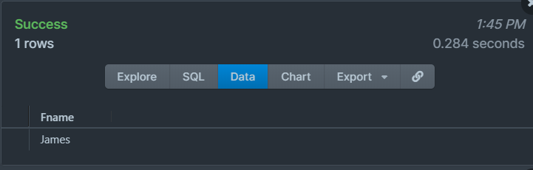

Q2.display second largest salary from employee table

**SELECT Salary FROM (SELECT Salary FROM Employee ORDER BY salary DESC LIMIT 2) AS Emp ORDER BY salary LIMIT 1;**

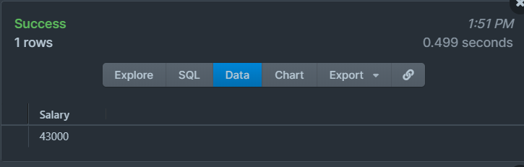

Q3.display fname of employee taking second largest salary 

**SELECT Fname, MAX(salary) AS salary FROM employee  WHERE salary < (SELECT MAX(salary) FROM employee);**

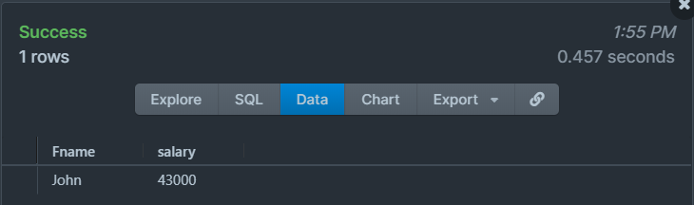

Q4. select fname and address of all the employees who work for 'Research' department

**SELECT FNAME, Address**

**FROM (EMPLOYEE JOIN DEPARTMENT ON DNO = DNUMBER)**

**WHERE DNAME = 'RESEARCH';**

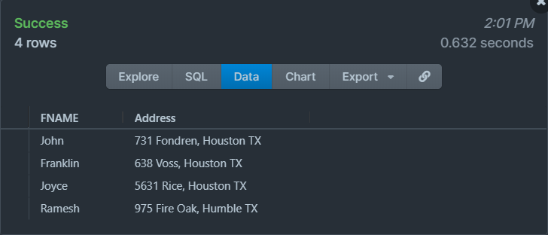

Q5. display name of employees whose salary is greater than the salary of all the employees in department 5

**select Fname, Lname from employee where Salary > ALL(Select Salary from employee where DNO = 5);**

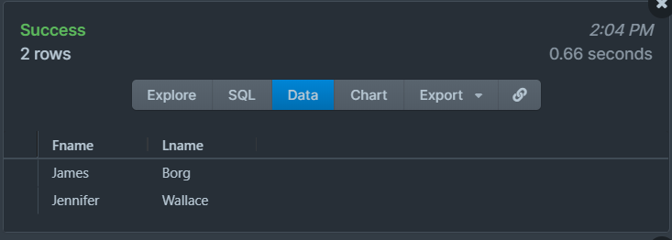

Q6. select ssn of employee who work on the same (project,hours) combination that employee 'john smith' works on

**select Essn from works_on where (Pno, Hours) in (select Pno, Hours from works_on where essn in (select Ssn from employee where Fname='John' and Lname='Smith'));**

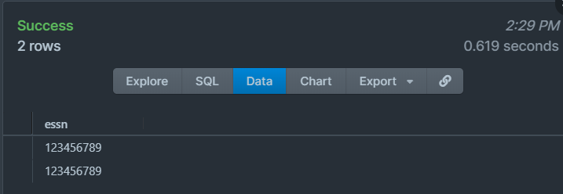

Q7. retrieve the name of each employee whose salary is greater than his own departments average salary.

**Select E.FNAME, E.LNAME FROM employee E where E.SALARY > (SELECT AVG(SALARY) FROM EMPLOYEE S WHERE E.DNO=S.DNO);**

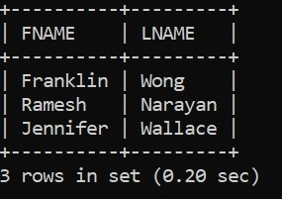

Q8. retrieve the name of each employee who has dependent with the same gender as the employee itself.

**SELECT FNAME, Lname, Employee.Sex AS ESex, dependent.Sex AS DSex**

**FROM EMPLOYEE, DEPENDENT WHERE SSN=ESSN AND Employee.Sex=Dependent.Sex;**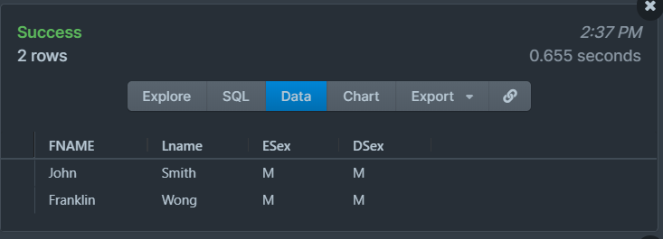

**CONCLUSION:** Database is searched for various nested and correlated queries.